|  |  |
| --- | --- |
|  |  |

Project specification: Utility Portal:

1. Time of use form field has different data types associated with different fields as below:

Effective date field data type: date

Time associated with time of use period: Time

Time of use period: It is drop down menu to select ON-Peak, off peak, and mid peak (data type varchar)

Time of user Price (TOU price): It accept number values only.

2. Entered data in from will be saved on web server in associated data format for each field.

Testing Plan for Utility Portal:  
 1. Data entered via utility portal operated will be tested relative to the field format via checking the file saved on the portal back end via accessing portal backend server side.

2. Python Script is responsible for fetching data from utility. Fetched data correctness will be verified via comparing it with files saved on portal server.

Thermostat model: Block diagram

Battery 9V

Pull up Resistor

GPIO PIN

5V

Switching Circuit

Air-conditioner

Temperature

Sensor

Raspberry pie

Controller 3B

GPIO PIN

Heater

Switching Circuit

Battery 9V

Figure 1.0

Thermostat model specifications:

1. Accuracy of sensing unit is +/- 0.5 ֯ C from -10 ֯ C to 85 ֯ C. Sensor’s actual temperature measurement range lies between -55 ֯ C to 125 ֯ C. Operating voltage range for sensing unit is 3.0 volt to 5.5 volt.

2. One wire protocol (proprietary serial communication) for communication with Microcontroller.

3. Software development for reading temperature with different resolution of 9 bit to 12 bit can be configured.

4. Set point is set to lower than current indoor temperature: Turn the Air-conditioner ON.

5. Set point is Set Higher than current indoor temperature: Turn the Heater ON.

6. Although, scheduler is responsible for switching thermostat loads. But user can override the scheduler setting via manually setting set points.

Testing plan for Thermostat model:

|  |  |  |
| --- | --- | --- |
| S/N | Tasks to Accomplish | Task results meet the specifications  (Y/N) |
| 1. | Temperature sensing unit accuracy verification.  Steps are as follows to verify the accuracy of measured temperature.  1. In order to verify the temperature measuring accuracy of temperature sensing unit, another temperature measuring tool is required as reference. It can be another reference thermometer. |  |
| 2. | Correctness Software development for sensor reading will be tested as follows:  1. Vary the temperature around temperature sensor using via placing hand on sensor or placing sealed ice pack safely. Then print the sensor reading on LCD to verify sensor readings.  2. Sensor temperature measurement range and resolution similarly verified via displaying sensor reading on control. |  |
| 3. | Load switching such as AC and heater  1. Set the set point below the room temperature and check if heater turns on or not. Similarly turns on set point higher than room temperature, if AC turns ON that verifies the accuracy of load switching and software development of it. |  |

Interfacing of Current transformer with Microcontroller to monitor power usage: Block diagram

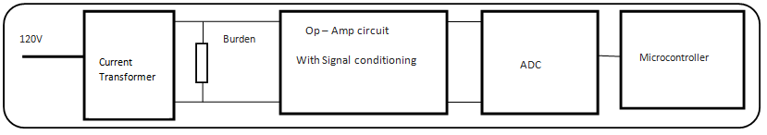

Figure 1.2

Specifications:

1. Current transformer must have 120 VAC as in input and maximum it can handle is 34 A when both primary windings are connected in parallel. Turn ratio of selected transformer is 200:1:1.

Accuracy of measurement with Ammeter clamp is 2.0 % ±5 digits (45 – 65 Hz)

2. In order to interface current transformer with microcontroller ADC for monitoring purpose, voltage range should be 0 to 3.3 V AC.

3. Burden resistor selection at the secondary of CT must be anticipated according to maximum current drawn in the circuit and must fulfills the requirement of required voltage that can be fed to Op-Amp and signal conditioning circuit.

4. Output of Signal conditioning circuit must be 0 to 3.3V.

Risk Assessment and mitigation strategy (RAMS):

|  |  |  |
| --- | --- | --- |
| S/N | Potential Hazardous dealing with 120 AC  Testing Environment : Power Lab | Mitigation Strategy |
| 1. | Trip and Fall Hazard | Clear the trip hazard from the way. |
| 2. | Electric Shock Hazard | Be mindful of shock and make connections very carefully. Try to use one hand while making connections. |
| 3. | Fire Hazard (If more current passed than rated values of component and devices. | Be mindful will connecting current rating loads. Verify connections and load ratings with Supervisor before turning ON anything. |
| 4. | Exposed electrical wiring | Proper inspection of wiring before powering ON Something. If there is exposed wiring, replace it with correct wire in good condition. |

Testing Plan for CT and controller interfacing circuit:

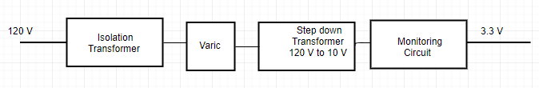

Figure 1.3

|  |  |  |
| --- | --- | --- |
| S/N | Testing of Monitoring unit  Input voltage for monitoring unit is 120 V and Output Voltage must be 3.3 V. Current on the secondary of step down transformer must be 34 A. Steps are given below to test the monitoring circuit. | Task results meet the specifications  (Y/N) |
| 1. | To safely perform testing of monitoring circuit which deals with high voltages and current rating .So, Isolation transformer must be connected between variable transformer and 120 V input supply |  |
| 2. | Then connect the step down transformer after variable transformer. Step down from 120 V AC to 10 V. Use Demonstration transform available in power lab as step down. |  |
| 3. | Connect Ammeter Clamp on the secondary of Step-down transformer to verify current on the primary of CT. If Ammeter reads 34 Amp which corresponds to 3.3 Volt on the output side of Monitoring Circuit |  |